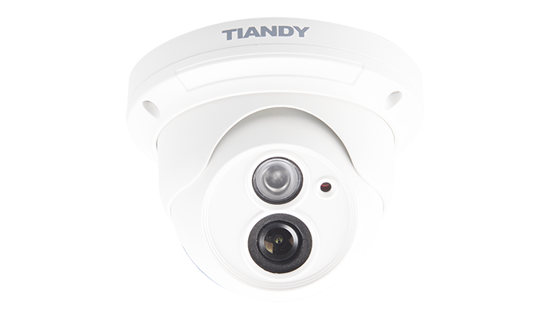

Features

• H.265 Codec  
• Up to 2560×1440@25fps  
• IR Range: 20m～30m  
• NIR, WDR, 3D DNR, HLC, Dual-ICR  
• Triple Streams  
• Smart VQD(Video Quality Diagnosis)  
• Crowd Massing Detection  
• 8 Kinds Smart IVA  
• 9 Languages Supported  
• TVS 6000V Protection, IP66

Specification

|  |  |
| --- | --- |
| Camera | |
| Image Sensor | 1/3″ OV CMOS |
| Core Processor | ARM7 Architecture |
| Operating System | Embedded Linux |
| Signal System | PAL/NTSC |
| Min. Illumination | Color: 0.05 Lux @(F1.2, AGC ON) |
| B/W: 0.01Lux @(F1.2, AGC ON); 0 Lux with IR ON |
| Shutter Time | 1s～1/100000s |
| Lens | 2.8mm/4mm/6mm, Angle of View: 99.2°/70.4°/48° |
| Lens Mount | φ12 |
| Auto Iris | N/A |
| Day& Night | IR Cut Filter with Auto Switch |
| Wide Dynamic Range | 100 dB |
| Digital Noise Reduction | 3D DNR |
| Compression Standard | |
| Video Compression | H.265/H.264 HP/MP/BP/M-JPEG |
| Encode Type | High Profile/Main Profile/Base Line Profile |
| Bit Rate | 32Kbps~16Mbps |
| Audio Compression | G.711/G.726/ADPCM/AAC |
| Bit Rate | 8K~48Kbps |
| Image | |
| Max. Image Resolution | 1440P(2560×1440) |
| Frame Rate | PAL：1440P@25fps,QXGA@25fps |
| NTSC：1440P@25fps,QXGA@30fps |
| Triple Stream | Mainstream: 1440P(2560×1440) |
| Substream: D1(704×576) |
| 3rd Stream: CIF(352×288) |
| Image Settings | Brightness, Saturation, Contrast, Flip Mode Adjustable by Client Software or Web Browser |
| HLC | Y |
| Smart Defog | Y |
| Corridor | Y |
| EIS | Y |
| ROI | 4 Zones |
| OSD | 16×16, 32×32, 24×24, 48×48, 64×64, 96×96 Size Letters Such as Week, Date, Time, Total 5 Regions |
| Privacy Mask | 4 Zones |
| Picture Overlay | 200 × 200, BMP 24bit, Zone Configurable |
| Network | |
| Browser | IE 7+, Chrome 18 +, Firefox 5.0 + |
| Network Storage | NAS |
| Video Analytics | Tripwire/Perimeter/Missing&Foreign Object/Loitering/Running/Parking/Gathering/Video Diagnosis/Abnormal Detection |
| Alarm Trigger | Motion Detection/IP Conflict/MAC Conflict/Port Alarm |
| Protocols | TCP/UDP/HTTP/MULTICAST/UPnP/DHCP/PPPoE/DDNS/NFS/ FTP/NTP/RTP/RTSP/IPv6/SNMP/SMTP/802.1X/QoS |
| User Permission | 4 Level/8 Users |
| Remote Connection | 2-ch Access |
| System Compatibility | ONVIF (Profile S),  SDK |
| Interface | |
| Audio Input | N/A |
| Audio Output | N/A |
| Communication Interface | 1-ch RJ45 10M / 100M Ethernet Interface |
| Alarm Input | N/A |
| Alarm Output | N/A |
| Video Output | N/A |
| On-board Storage | N/A |
| Extension | N/A |
| General | |
| Languages | English, Spanish, Korean, Italian,Turkish,Thai, Russian, Simple Chinese, Traditional Chinese(Hebrew, Polish Optional) |
| Operating Conditions | -35℃～60℃(IR OFF) /-35℃～40℃(IR ON), 0～95% RHG |
| Power Supply | DC12V±25%/1A, PoE (802.3af) |
| Power Consumption | Max. 3W(IR OFF) |
| Max. 5.85W(IR ON)(ICR Instant Switch 7W) |
| Circuit Protection | TVS6000V Lightning/Surge Protection: (Power 2000V, RJ45 1000V) |
| Impact Protection | IP66 |
| IR Range | 20m～30m |
| IR LEDs | 1pcs IR Array LEDs |
| Dimensions | 121mm×121mm×91mm |
| Weight | 500g (IP Camera Only); 700g (with Packing Box) |

Dimension

